



Technical Design documentation

Document History

|  |  |  |  |
| --- | --- | --- | --- |
| Version | Updated By | Date | Comments |
| 1.1 | Vamshi Vushakola  Rohit John Alex | 29/02/2016 | Initial Draft |
| 1.2 | Vamshi Vushakola  Rohit John Alex | 07/03/2016 | Added Class diagram, Sequence diagram and Use case diagram |
|  |  |  |  |

Document Sign-Off

|  |  |  |
| --- | --- | --- |
| Name | Role | Signature/Date |
| Gyaneshwar Dubey | Manager |  |
|  |  |  |
|  |  |  |

Table of Contents

1. Introduction 3

1.1 Authentication: 3

1.2 Request an account. 3

2. Installation and Configuration 4

2.1 Installing the B2B Early Login AddOn 4

2.2 Content Catalog 5

2.3 Impexes 5

2.4 Update 7

2.5 Early Login Page 7

1. Introduction

## Authentication:

Users are required to authenticate before being able to browse the site. Password recovery is provided from the early login page that is displayed when a user tries to access the site and this feature is enabled.

The secureportaladdon AddOn requires users to authenticate before being able to browse the site.

The secureportaladdon AddOn is included in the b2b_acc_plus installation recipe, which includes all B2B AddOns.

When the AddOn is installed, the features of the secureportaladdon AddOn are enabled automatically.

## Request an account.

The link to do so appears in two places: in the early login page, and in the header, if the user is not logged in.  The new account is approved by a merchant user who is part of the b2bregistrationapprovergroup group.

1. Installation and Configuration

## Installing the B2B Early Login AddOn

1. The B2B Early Login AddOn is installed using ant addoninstall.
2. Ensure that secureportaladdon is listed in config/localextensions.xml and that the entries are not commented out, as shown in the following example.
3. Config/localextensions.xml

|  |
| --- |
| ...  <extension name="secureportaladdon" />  ... |
|  |

1. Run the following ant task:

|  |
| --- |
| ant addoninstall -Daddonnames="secureportaladdon" -DaddonStorefront.asianpaintsb2bstorefront="asianpaintsb2bstorefront" |

1. Run ant all.
2. Rebuild the system.
3. In the hybris Administration Console ([localhost:9001](http://localhost:9001/)):
4. Update the system (**Platform** > **Update**), use the following options:
5. Select the options **Update running system**, **Create essential data**, and **Localize types**.
6. In the project data settings, select the **secureportaladdon** check box, and set **Sync Content Catalogs** to **yes**.
7. Click **Update**.

## Content Catalog

Now import secureportaladdon to workspace and navigate to secureportaladdon/resources/secureportaladdon/import and copy powertoolsContentCatalog folder and rename it as our own custom content catalog (asianpaintsb2bContentCatalog) and paste in that folder only like below.

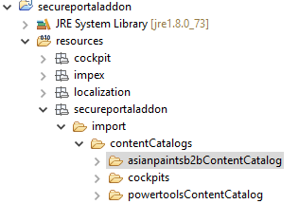

## Impexes

**cms-content.impex**

|  |
| --- |
| /secureportaladdon/resources/secureportaladdon/import/contentCatalogs/asianpaintsb2bContentCatalog/cms-content.impex |

**cms-content_en.impex**

|  |
| --- |
| /secureportaladdon/resources/secureportaladdon/import/contentCatalogs/asianpaintsb2bContentCatalog/cms-content_en.impex |

1. After making changes in impexes, go to hAC/Console/ImpEx Import and import both cms-content.impex and cms-content_en.impex files.
2. After Successful import go to secureportaladdon/project.properties file and override this below code

yacceleratorstorefront.additionalWebSpringConfigs.secureportaladdon=classpath:/secu reportaladdon/web/spring/secureportaladdon-web-spring.xml

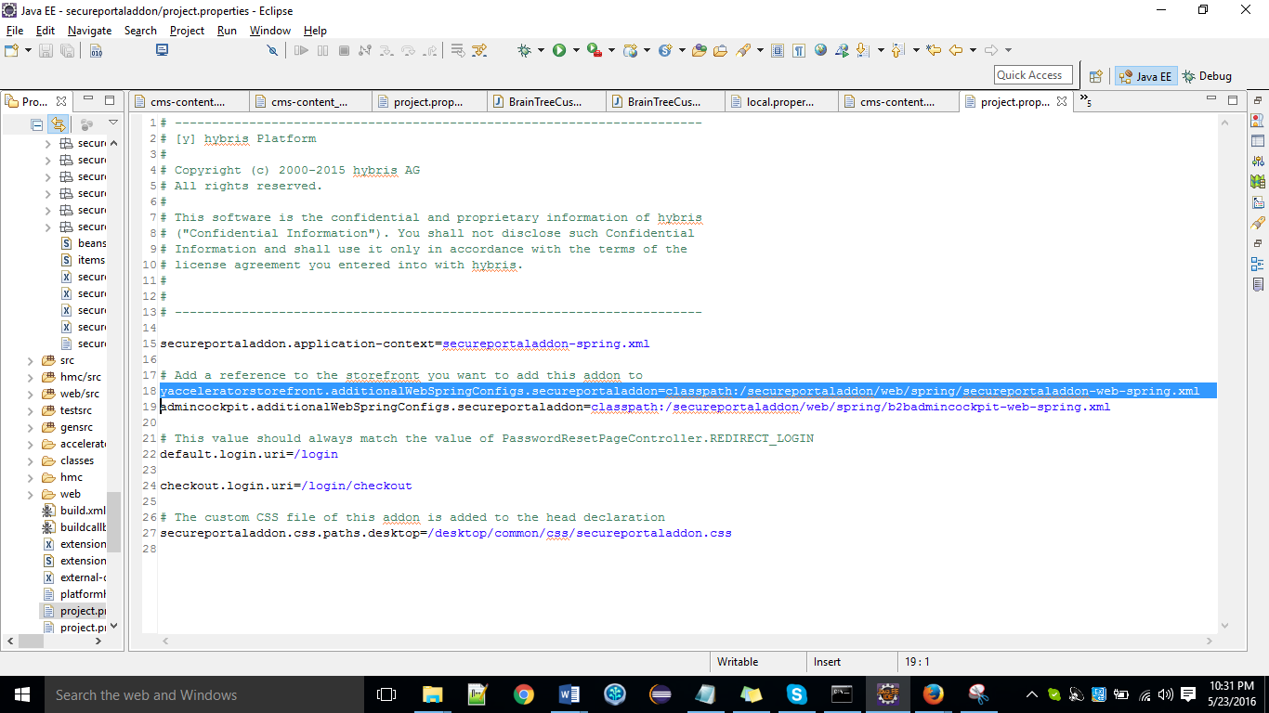

in config/local.properties file as

asianpaintsb2bstorefront.additionalWebSpringConfigs.secureportaladdon=classpath:/secureportaladdon/web/spring/secureportaladdon-web-spring.xml

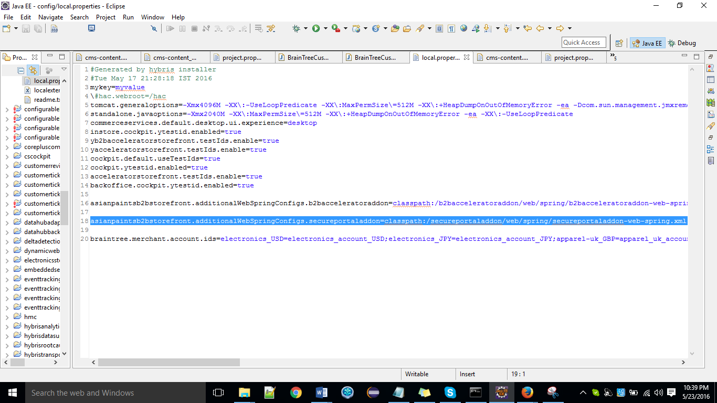

**project.properties:** Provides factory default settings. It is not recommended to edit this file.

|  |
| --- |
| /secureportaladdon/project.properties |

**Local properties:** This is the working copy of the project.properties file that will be found in the config folder. Use this file to override the default hybris settings.

|  |
| --- |
| /config/local.properties |

## Update

1. Now restart hybris server
2. Go to hAC >> platform >> update >> secureportaladdon

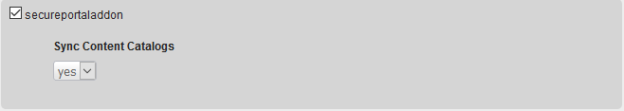

## Early Login Page

As shown in the following example, when the B2B Early Login AddOn is enabled, the early login page that is displayed is a "bare" page – there is no header or footer, or any links that could expose the rest of the site.

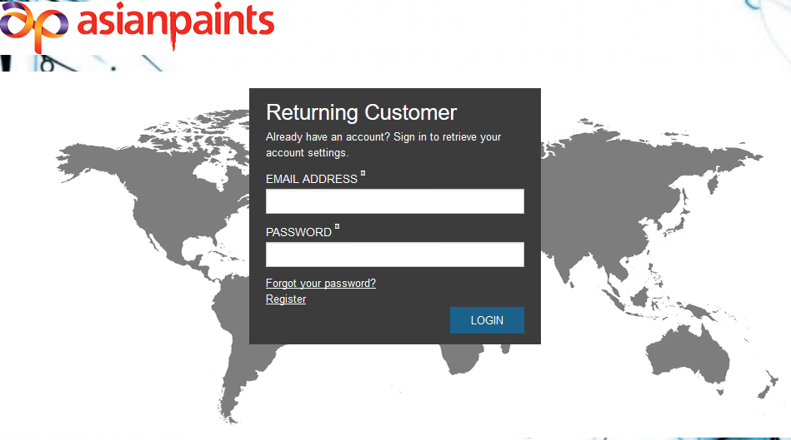

|  |
| --- |
| This Zip file contains all Impexes, Java Classes, xml files and properties file. |
|  |